Kevin Pinto

CS225 Software Development

MaintainProj part 2: Yuliia, Christian, Kevin, Alland

**Tasks List**

**Bugs:**

**Kevin {  
1)** After clicking simulate button the only options are ScoreBoard or View Simulated Bracket, there’s no way to exit the game, return to the login screen, start a new bracket, etc:

**}**

**Yuliia {**

**2)** There is no greeting or welcome message for the users, as it is mentioned in the requirements to

greet the user.

**3)** Special characters should not be allowed in usernames

}

**Improvements:**

**Kevin {**

1. Allow User to reset brackets and start from the beginning. (From what I’m seeing, I’m not

able to do anything but exit out of the program once simulated.) **}**

**Christian {**

1. Clarify, in the GUI, that if you do not already have an account, that one will be created for

you upon login attempt. Alternatively, have a separate sign-up page. Save information if not already.

3) If I try to login with empty fields, it should show an error message, and highlight where the error is occuring.

4) Allow Users to see their submitted predictions along with others. Have some sort of highlighting

**}**

**Alland {**

5) No indication what is missing when clicking Simulate, very hard to tell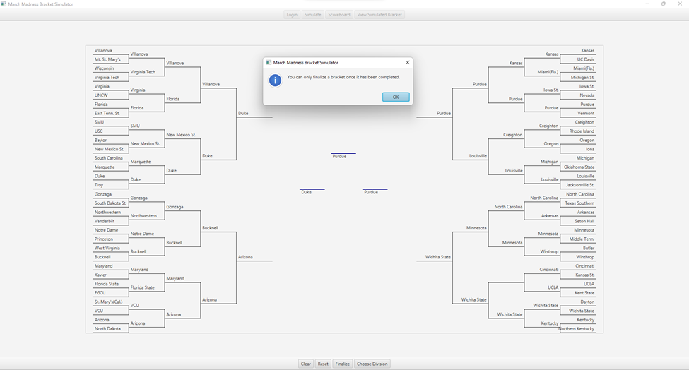

1. There should be a Pop up dialog to tell the user about his score when he clicks to check to for his

result **}**

**New Features:**

**Kevin {**

1. Add a logout button
2. Add a new bracket button
3. Exit button **}**

**Alland (tentatively) {**

1. Correct guesses highlighted in green
2. Incorrect guesses highlighted in red }

**Yuliia {**

1. Greeting message for user
2. Add descriptions to each page to direct the user on the purpose of the page/what to do next.
3. Error message if attempting to sign in with blank username/password **}**

**Stretch Goal:**

1. Have more dynamic resizing for UI